**Problem 1:**

1. Navigate the List:

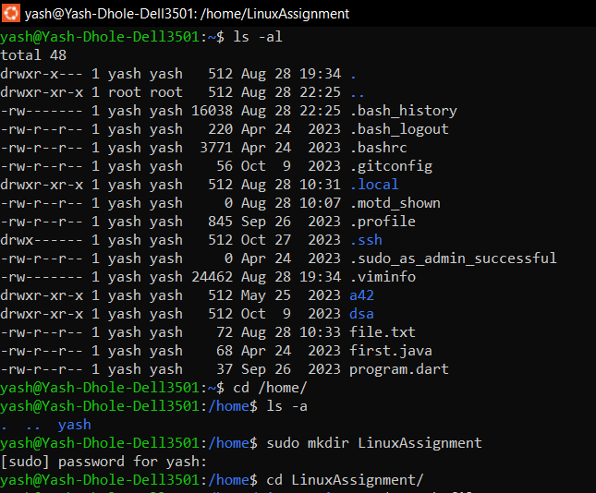

1. File Management:



1. Directory Management: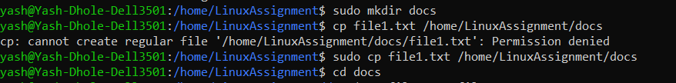
2. Copy and Move Files:



1. Permission and Ownership:
2. Final Checklist:



1. File Searching:

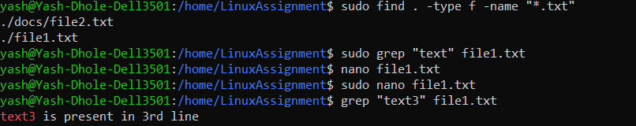

1. System Information:



1. Networking:

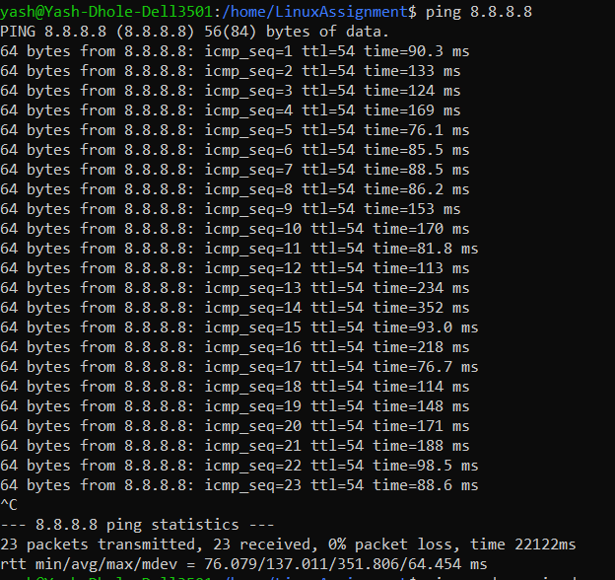

1. File Compression:

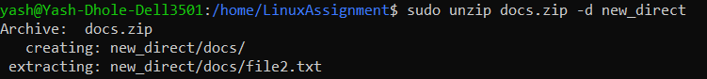

a.



b.

**Problem 2:**

1. First 10 line of file:

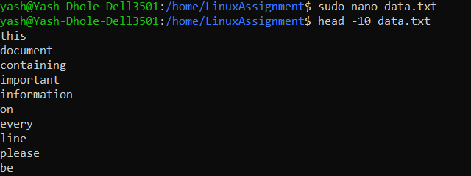

1. Recent 5lines added in file:

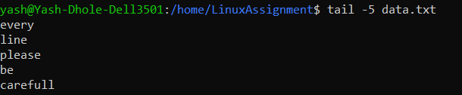

1. 15 lines of number series:

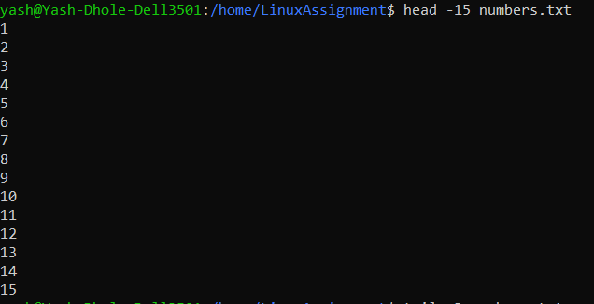

d)Last few numbers:

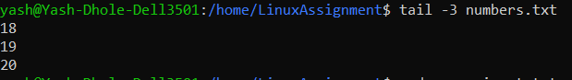

1. Convert all lower case to upper case of one file and save it to another one (input.txt to output.txt). :



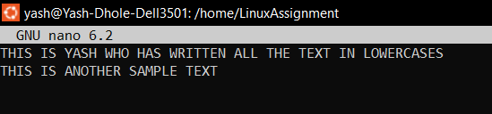

1. Display unique lines from duplicate.txt

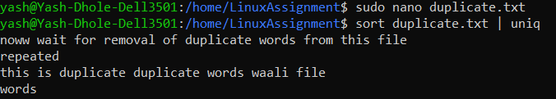

1. Occurrence of fruit:

